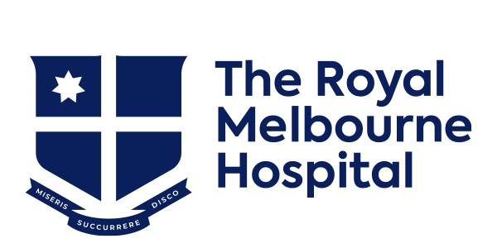

2024 Stroke Clinical Fellow

The Royal Melbourne Hospital Department of Neurology is offering a 1-year stroke clinical fellowship position in 2024. This role will provide excellent exposure to stroke clinical medicine in a world class comprehensive stroke centre, including experience in the management of hyper-acute stroke, thrombolysis, endovascular therapy, cutting edge management of intracerebral haemorrhage, brain imaging, clinical trials, and prehospital stroke care on the Melbourne Mobile Stroke Unit (MSU).

Candidates who have completed 2 years of ANZAN neurology advanced training (core), or equivalent, will be considered. Depending on performance, there will be an opportunity to extend the 1-year fellowship into a higher degree such as a PhD.

Interested applicants, please send a cover letter and CV Ms Narelle Cullen, RMH Neurology Department - narelle.cullen@mh.org.au PH: 03 9342 22960. Applications close 31 May 2023.

